
3. Setup a Jenkins CICD pipeline using Scripted pipeline using feature-1.1 branch. https://github.com/betawins/sabear_simplecutomerapp/tree/feature-1.1
stages:
Git Clone
SonarQube Integration
Maven Compilation
Nexus Artifactory
Slack Notification
Deploy On tomcat

Implementation:
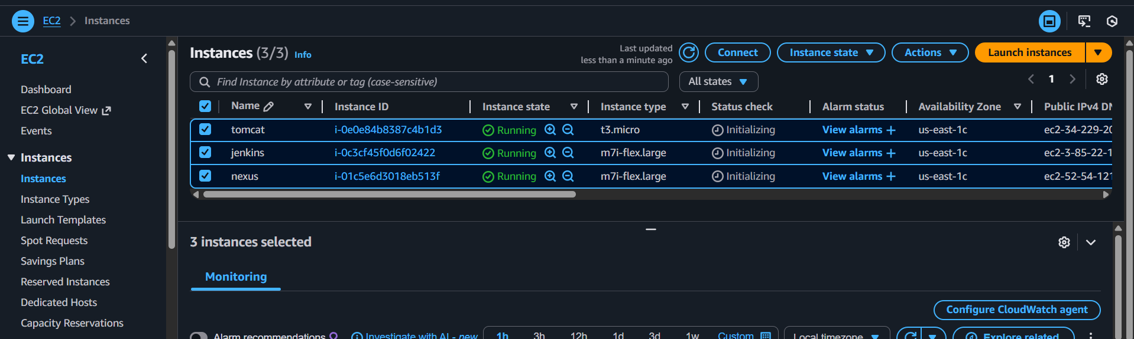
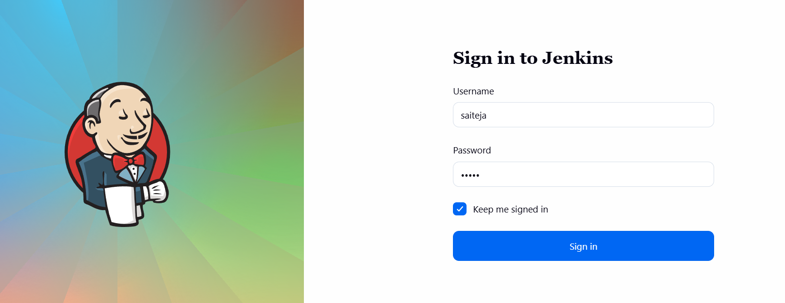

Install a plugin called Stage view for viewing in stages
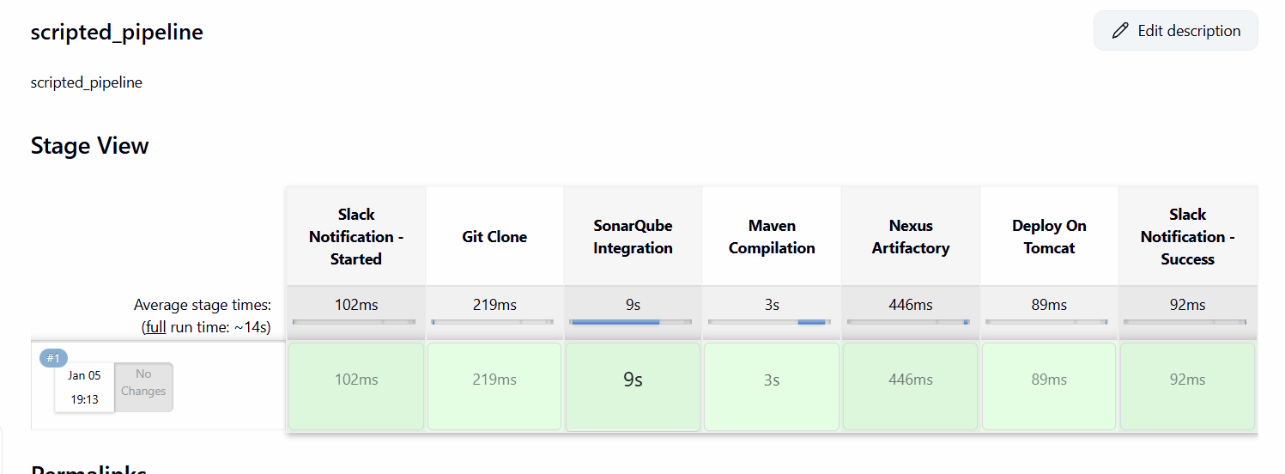

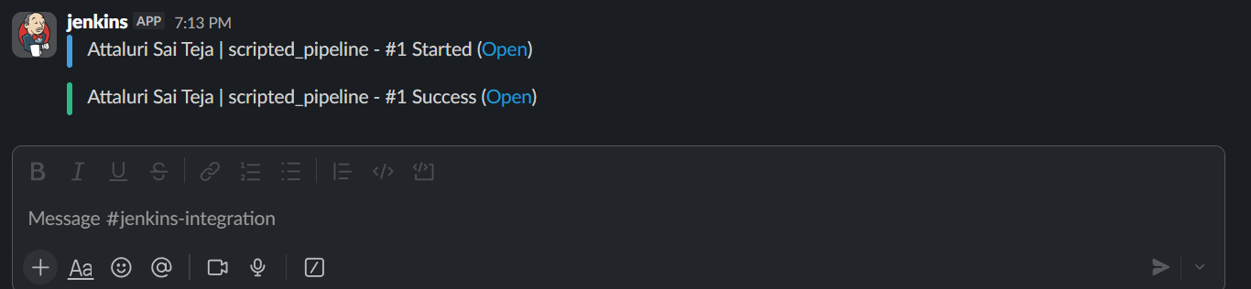
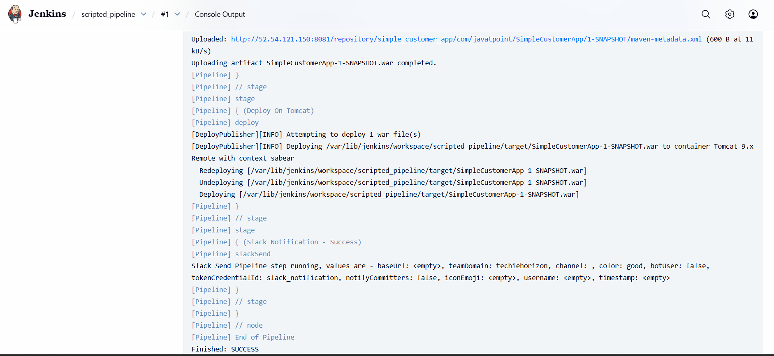
NOTE::
Check the url and credentials twice before clicking on build that can cause the errors

Pipeline script:::
node {
// ---------------- ENV SETUP ----------------
env.MAVEN_HOME = '/opt/apache-maven-3.9.12'
env.PATH = "${env.MAVEN_HOME}/bin:${env.PATH}"

env.SONAR_PROJECT_KEY = 'sabear_simplecustomerapp'
env.SONAR_PROJECT_NAME = 'SimpleCustomerApp'

env.NEXUS_URL = '52.54.121.150:8081'
env.NEXUS_REPOSITORY = 'simple_customer_app'

env.TOMCAT_URL = 'http://34.229.204.43:8080'

try {
// ---------------- SLACK : STARTED ----------------
stage('Slack Notification - Started') {
slackSend(
color: '#439FE0',
message: "Attaluri Sai Teja | ${env.JOB_NAME} - #${env.BUILD_NUMBER} Started (<${env.BUILD_URL}|Open>)",
tokenCredentialId: 'slack_notification'
)
}

// ---------------- GIT CLONE ----------------
stage('Git Clone') {
git branch: 'feature-1.1',
url: 'https://github.com/betawins/sabear_simplecutomerapp.git'
}

// ---------------- SONARQUBE ----------------
stage('SonarQube Integration') {
// Using 'sonar-server' to match your Jenkins configuration
withSonarQubeEnv('sonar-server') {
sh """
mvn clean verify \
org.sonarsource.scanner.maven:sonar-maven-plugin:sonar \
-Dsonar.projectKey=${env.SONAR_PROJECT_KEY} \
-Dsonar.projectName=${env.SONAR_PROJECT_NAME}
"""
}
}

// ---------------- MAVEN BUILD ----------------
stage('Maven Compilation') {
sh 'mvn clean package -DskipTests'
}

// ---------------- NEXUS UPLOAD ----------------
stage('Nexus Artifactory') {
def warFile = sh(
script: "ls target/*.war",
returnStdout: true
).trim()

nexusArtifactUploader(
nexusVersion: 'nexus3',
protocol: 'http',
nexusUrl: env.NEXUS_URL,
repository: env.NEXUS_REPOSITORY,
credentialsId: 'nexus_server', // Confirmed ID from your previous stages
groupId: 'com.javatpoint',
version: "${env.BUILD_NUMBER}-SNAPSHOT",
artifacts: [[
artifactId: 'SimpleCustomerApp',
classifier: '',
type: 'war',
file: warFile
]]
)
}

// ---------------- TOMCAT DEPLOY ----------------
stage('Deploy On Tomcat') {
deploy adapters: [
tomcat9(
credentialsId: 'tomcat', // Confirmed ID from your previous stages
url: env.TOMCAT_URL
)
],
contextPath: 'sabear',
war: 'target/*.war'
}

// ---------------- SLACK : SUCCESS ----------------
stage('Slack Notification - Success') {
slackSend(
color: 'good',
message: "Attaluri Sai Teja | ${env.JOB_NAME} - #${env.BUILD_NUMBER} Success (<${env.BUILD_URL}|Open>)",
tokenCredentialId: 'slack_notification'
)
}

} catch (err) {
// ---------------- SLACK : FAILURE ----------------
slackSend(
color: 'danger',
message: "Attaluri Sai Teja | ${env.JOB_NAME} - #${env.BUILD_NUMBER} Failed (<${env.BUILD_URL}|Open>)",
tokenCredentialId: 'slack_notification'
)
throw err
}
}

